**Exercise 9.**

Analyzer IV Applications in Multisim

Table of Contents

List of Figures 1

Abstract 2

Part 1: Examination the characteristics of transistors 3

Part 2: Homework 8

# List of Figures

Figure 1 Regular Diode Layout 3

Figure 2 IV Analyzer Diode 3

Figure 3 Circuit Layout plus Zener Diode 4

Figure 4 Setting the parameters of the analyzer 5

Figure 5 JFET Analysis 6

Figure 6 BF245A Issue. 6

Figure 7 Simulation Results. 7

Figure 8 Analyzer Parameters. 7

Figure 9 The bipolar transistor amplifier. 8

Figure 10 Class A Calculations 8

Figure 11 Calculations 2 9

Figure 12 NPN Transistor BJT. 9

Figure 13 Oscilloscope Output. 10

Figure 14 AC Analysis 10

Figure 15 The JFET amplifier. 11

Figure 16 JFET Circuit. 11

Figure 17 JFET Oscilloscope Output. 12

Figure 18 AC Analysis. 12

# Abstract

The aims of this laboratory exercise were to learn the basics of using NI Multisim 10 simulation program:

* Learning the IV Analyzer application,
* Plotting of the dynamic characteristics for selected semiconductor devices,
* Transistor amplifiers designing.

# Part 1: Examination the characteristics of transistors

To begin testing we will firstly need to work on a diode, to present the working and operation.

Below please see the setup. We are using the IV Analyzer which is a built-in tool in Multisim.

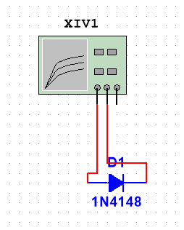

Figure 1 Regular Diode Layout

Below please see the first setting parameters of the analyzer.

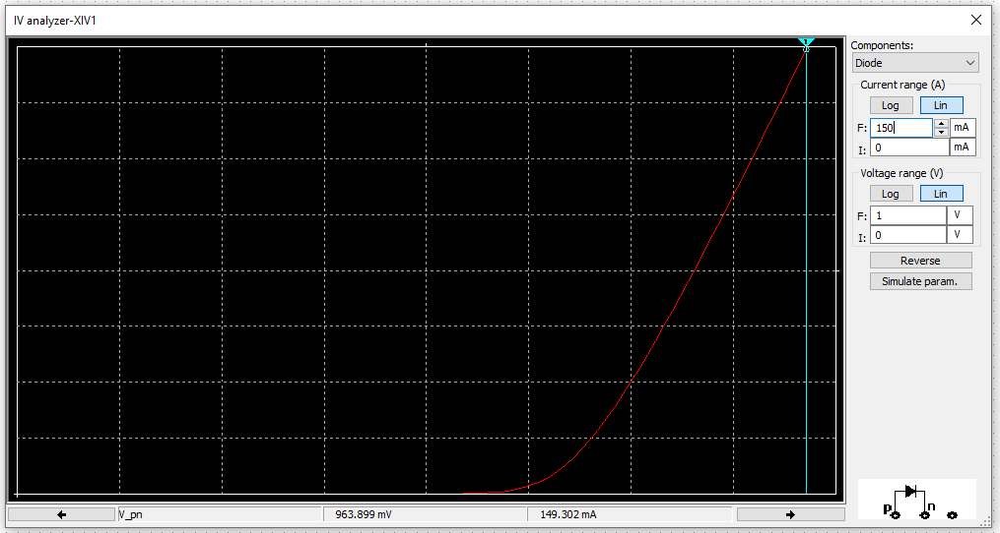

Figure 2 IV Analyzer Diode

From the figure above we see that the 1N4148 is in fact a Rectifier diode that starts to enable current flow at 150µA. Of course, this is the ideal scenario simulation since the diode for example at negative voltages would break. If we were to set the negative voltage the Analyzer in Multisim will just show that the diode is not conducting. We can use the cursor to observe the following parameters that the forward current is 150mA. However, if we look at the data sheet, we see that this is confirmed but we also see that the reverse voltage that this diode can handle is 75V (with peak reverse voltage 100V).

Moving onto the next step we will test the Zener diode and we will observe what will occur. For simplicity we will use the 1N5226B Zener diode.

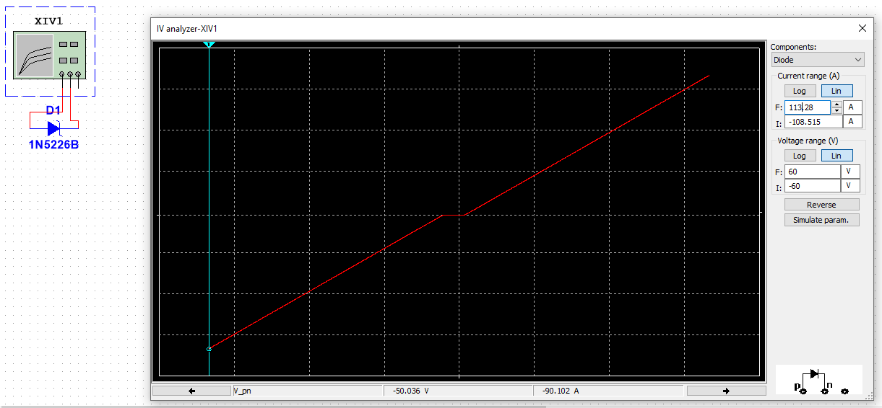

Figure 3 Circuit Layout plus Zener Diode

This characteristic is very large and from the pure eye we cannot see every main detail of the diode functioning.

For the next part we will start to move onto transistors, NPN type. In the instruction manual we are to use the BC337 however since we do not have the correct version of Multisim, we must use the next best thing, in this case it was the BC107BP (NPN) very common and often used in many applications. We put this transistor into the simulation window, and we connect the collector emitter and base according to the schematic presented in the IV Analyzer (bottom right) window. When placed we set the correct parameters. Here we use Uce = 0 – 10V with step of 10 and Ib 1-10mA but we used µA as suggested during laboratory introduction class from this exercise for a while. We select simulate and read the value of the current Ic using the cursors for when Uce for each base current (to do this select the trace by right click and Select Trace ID). Below please see the schema connection, the idealistically Analyzed window of the transistor as well as the cursor reading.

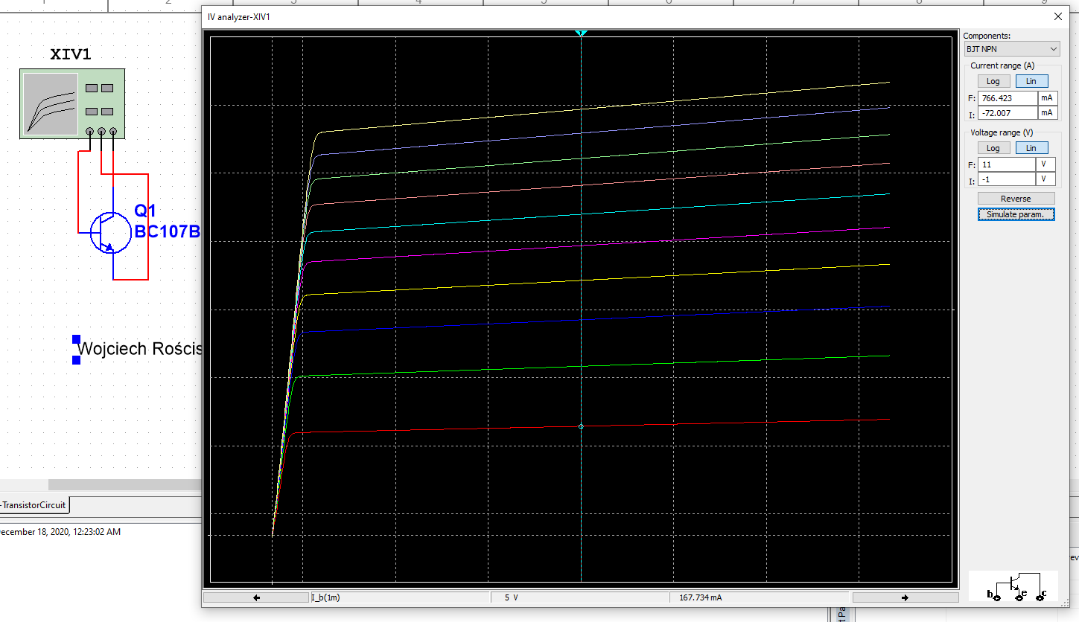

Figure 4 Setting the parameters of the analyzer

As seen in the above we are able to see the plot characteristic of the step functions in our transistor. We will measure the reading for when collector-emitter voltage is 5V, we need to find the current. As seen in the simulation window the collector current is presented at the bottom of the figure above, in this case the current being 167.7mA – this is for the 1mA for base current. We can right click and change the characteristic for example 5mA base current the collector current for 5V collector-emitter voltage is 445.3mA.

Now we must calculate the current gain characteristic. So, using the equation Ic/Ib we are able to find the Ku property (gain) of our transistor, in this case we have 167.7mA/1mA = 167,7. Now let’s select a higher base current, here Ku=445,3mA/5mA=89.06. If we perform the same in µA then we can get values such as Ib=10µA, Ic=3.023mA and beta (Ku) =302,3.

For the next part of the exercise we will be testing the characteristic of the FET transistor.

In the below please see the setting parameters of the analyzer.

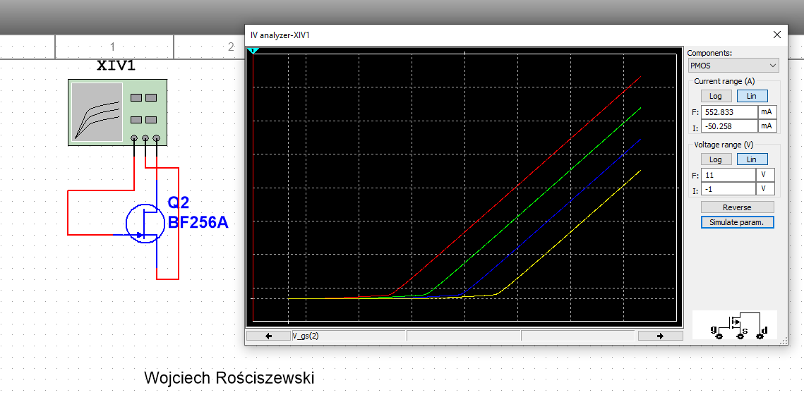

Figure 5 JFET Analysis

As visible in the above figure we have used the BST100 JFET transistor, in the analyzer we have selected the PMOS components for the IV Analyzer to function and present our desired results. Here I have used the BF256A replacement JFET N-Type transistor as the instructed in laboratory exercise BF245A was not working, more on this the transistor model was only presented but as a graphic, there was no simulation/sub circuit available for this part. I know this as the BF245A component presented green, this means that the component cannot be used in a simulation but can be used to present a layout of a circuit. Please see the figure below for reference.

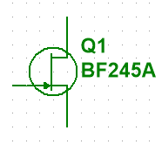

Figure 6 BF245A Issue.

FIX: I have been using the 14.2 Version of Multisim hence why this component was not available in the database.

As you see in the circuit above the results are linear, when we change the gain voltage we will be working between two data points, but vertically we change the output voltage – if 9.4V the output current is 724mA , we can say the transistor changes the input voltage for output current and in case of JFET transistor the gain coefficient is the output current divided by the input voltage. For example we will do this, we select around 5V as the input voltage and we see that the output current is 150.8mA. The gain coefficient in this case will be 150.8mA/5V = 0.03.



Figure 7 Simulation Results.

Below please see the next MOSFET exercise part, here we have used the 2n6804. Below please see the figure presenting the characteristic as well as circuit scheme used.

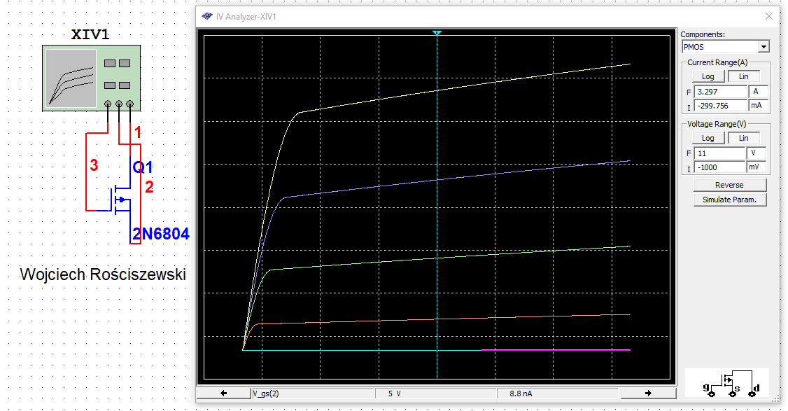

Figure 8 Analyzer Parameters.

Below please see a table consisting of all current Id values for each Uds = 5V.

|  |  |
| --- | --- |
| Id | Is |
| 2 | 8.8nA |
| 2.333 | 8.8nA |
| 2.667 | 8.8nA |
| 3 | 8.8nA |
| 3.333 | 8.8nA |
| 3.667 | 3.8mA |
| 4 | 327.3mA |
| 4.333 | 966.1mA |
| 4.667 | 1.78A |
| 5 | 2.72A |

Average value: 0.58.

Gain of this transistor is equivalent to the ratio of 0.116.

Conclusion, the transistor gain depends on many factors such as input voltage the characteristic of the transistor as well as its function in the circuit. We have clearly demonstrated this during the exercises, we see that the measured range is accurate enough for us to presents calculative results.

# Part 2: Homework

For this part of the exercise we will design amplifier with bipolar transistor (class A). Below please see a figure presenting the simple bipolar transistor amplifier.

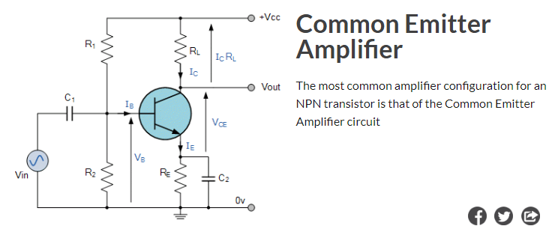

Figure 9 The bipolar transistor amplifier.

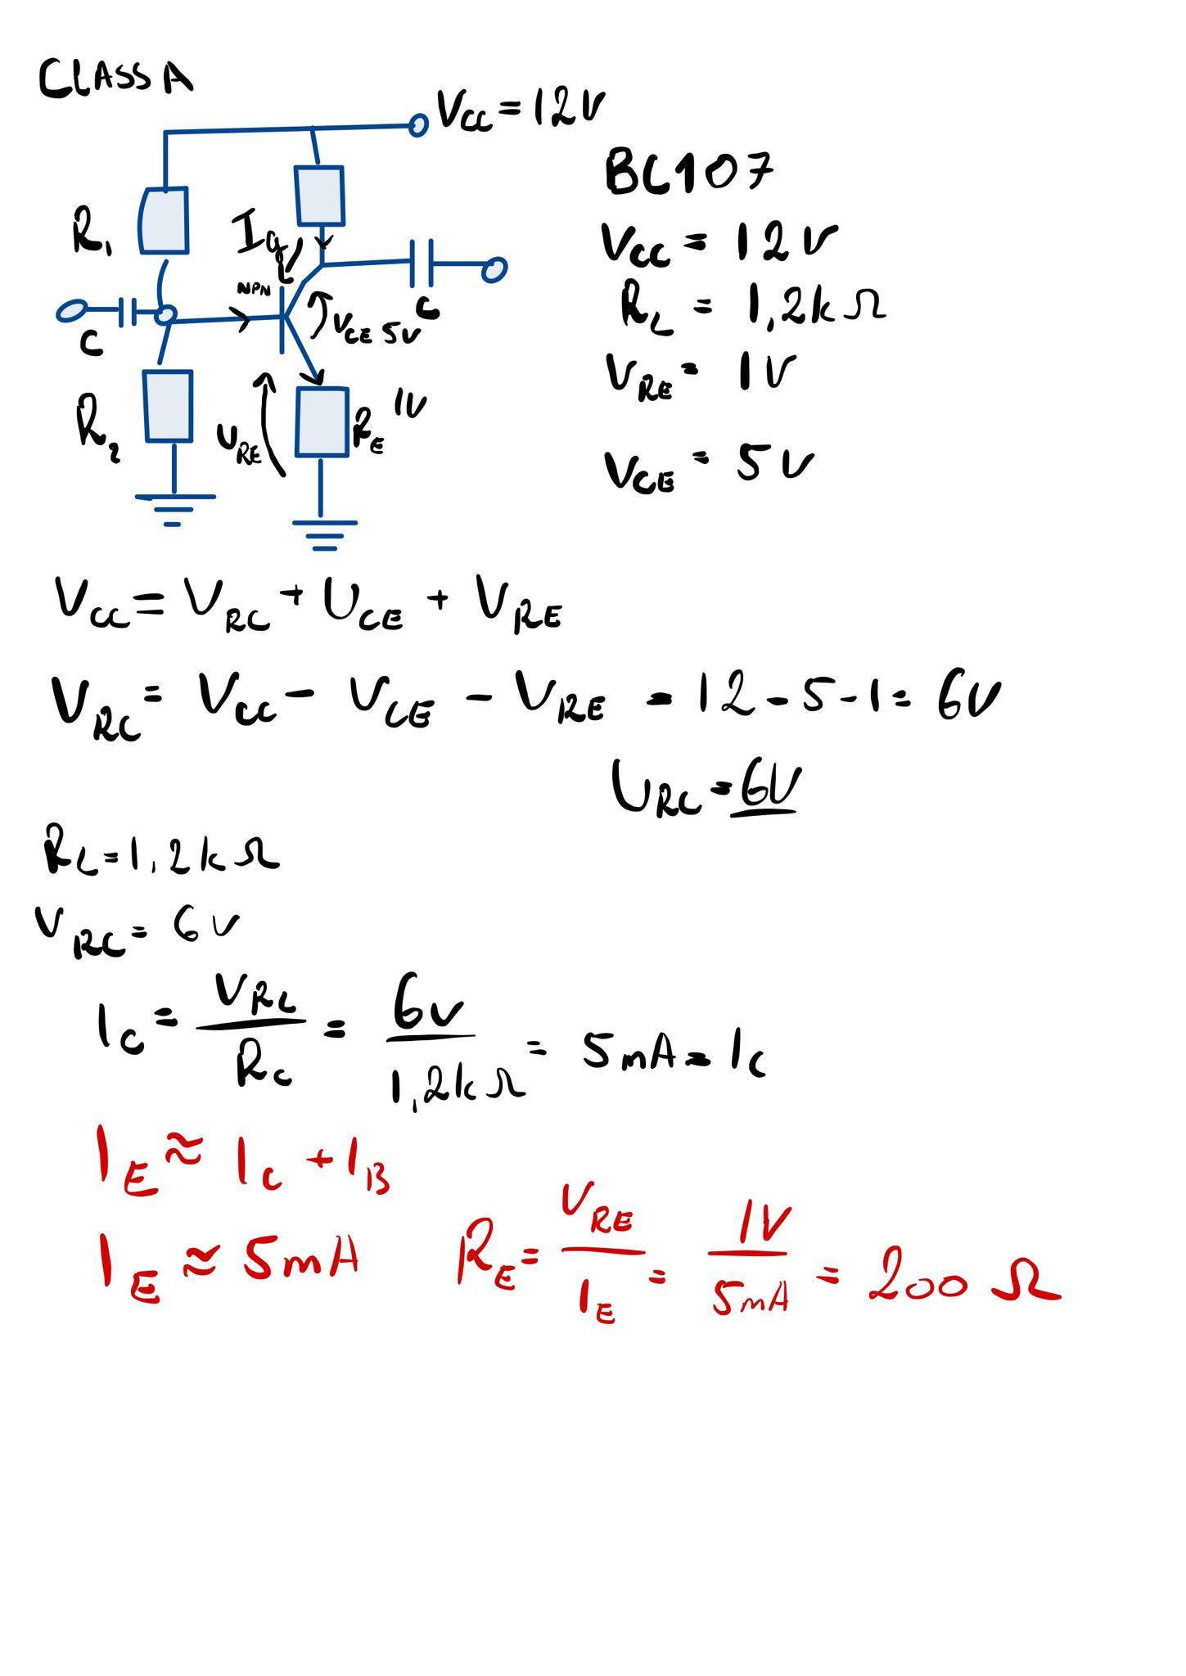

Figure Class A Calculations

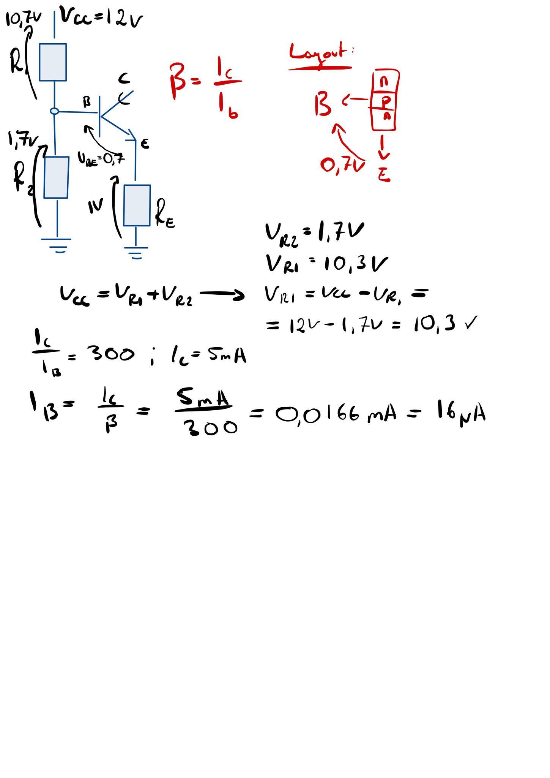

Figure 11 Calculations 2

Below please see the circuit used for simulation as well as the output results.

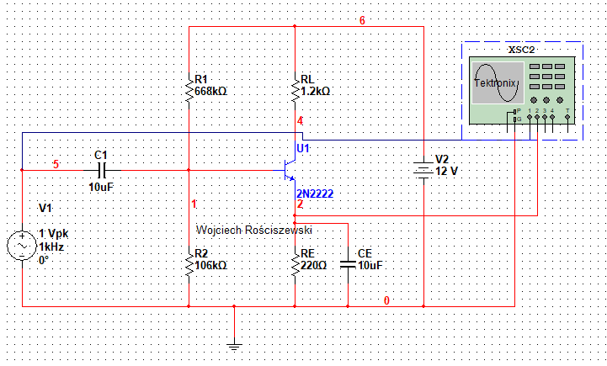

Figure 12 NPN Transistor BJT.

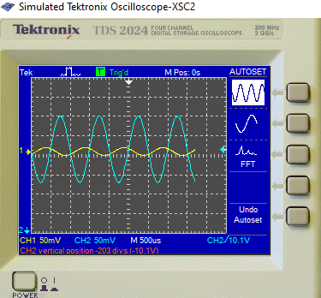

Figure 13 Oscilloscope Output.

Below please see AC Analysis:

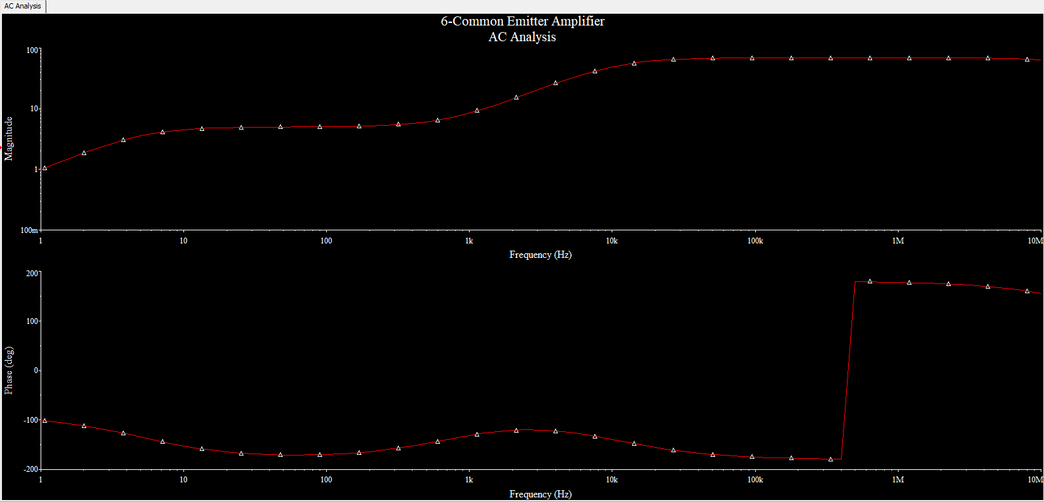

Figure 14 AC Analysis

For this part of the exercise we will design amplifier with FET transistor (class A). Below please see a figure presenting the simple with FET transistor amplifier.

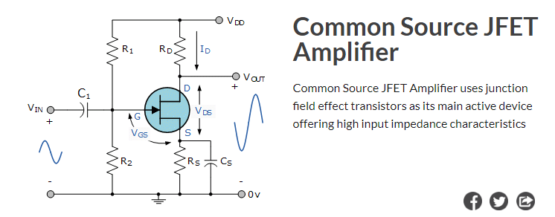

Figure 15 The JFET amplifier.

Below please see the circuit used for simulation as well as the output results.

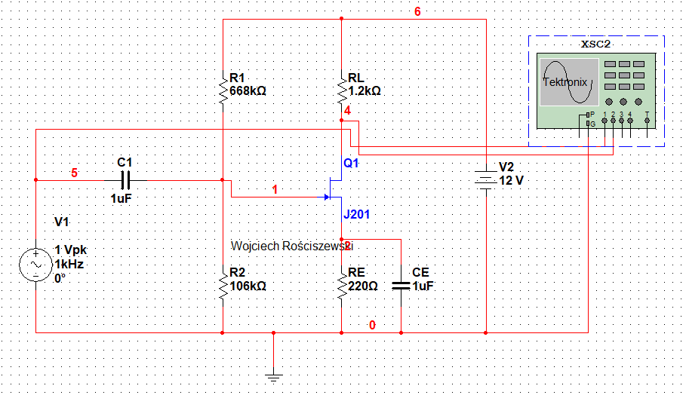

Figure 16 JFET Circuit.

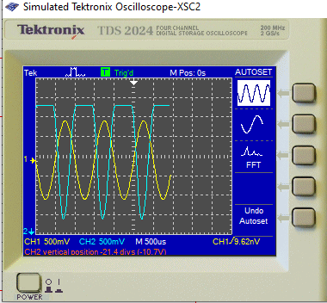

Figure 17 JFET Oscilloscope Output.

Below please see AC Analysis:

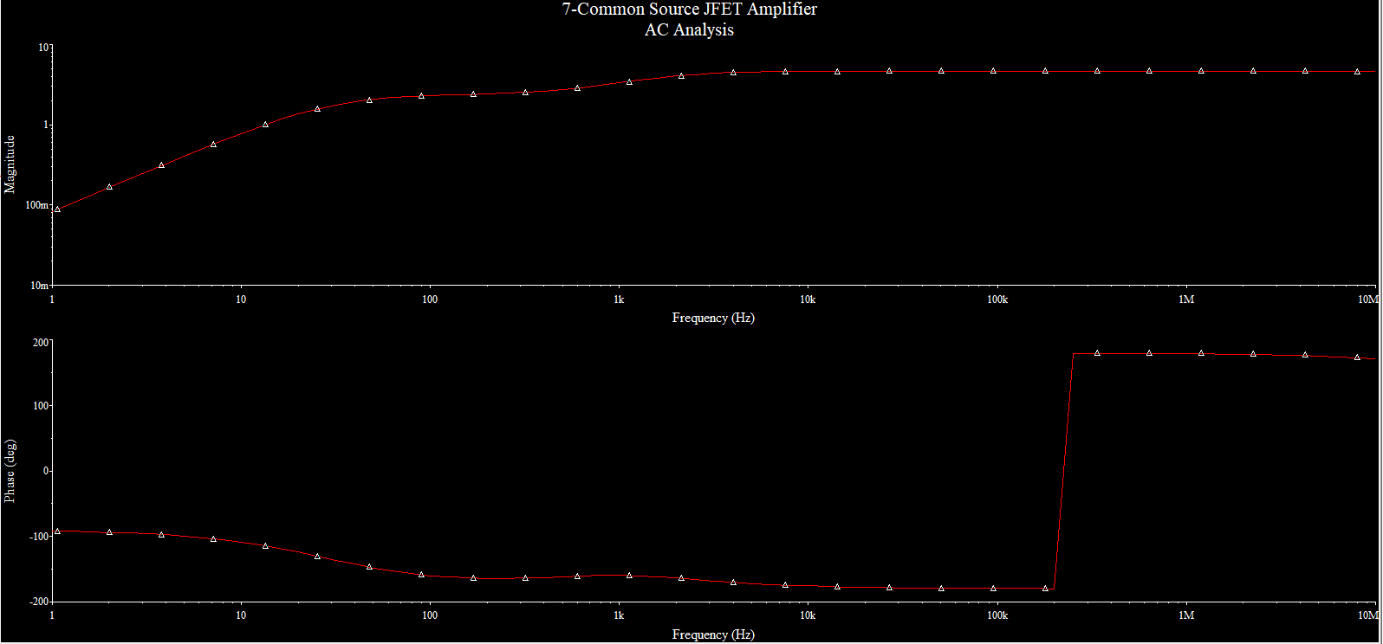

Figure 18 AC Analysis.

Conclusion: The BJT NPN Transistor is better see that in the JFET oscilloscope output figure the amplifier has a flat sinusoidal peak which means that it is overshoot meaning that in real life it isn’t the best amplifier for example for audio equipment. However we see that the JFET transistor amplifies more looking at the Hz scale for reference than the regular NPN transistor.